Required Capstone Checkpoint 4.1: Advanced Retrieval Implementation

Directions

Download this worksheet and save a copy to your device before you begin working. Use this worksheet to plan, organize, and complete your submission for Required Capstone Checkpoint 4.1. Type your responses directly into the document, save your completed work, and upload the finished file when you are ready to submit.
Completion Checklist
☐ Identification of a meaningful retrieval failure or limitation supported by evaluation evidence
☐ Analysis of the likely cause of the retrieval failure
☐ Selection and justification of an advanced retrieval strategy
☐ Evidence of implementation of the updated retrieval architecture
☐ Evaluation results comparing the updated system against the baseline system
☐ Reflection on the effectiveness of the architectural changes and any remaining limitations

Step 1. Retrieval Failure Identification
Identify a meaningful retrieval limitation in your current retrieval system.
- Describe the failure or limitation.
- Explain how the limitation affects retrieval performance.
- Reference evaluation evidence, test results, queries, or outputs that demonstrate the issue.
Retrieval failure or limitation
The current retrieval system (checkpoint 3.1) retrieves the top 3 documents using a hybrid BM25 + vector approach, but it is primarily optimized for finding documents that individually match a query. It is not designed to identify or synthesize relationships between multiple articles when the query requires comparing documents or finding an implicit connection across them. This limitation is visible in queries that require reasoning beyond a single article's content.

Evidence supporting the identified limitation
"What is the connection between two unrelated articles?"
The hybrid retrieval returned:
('Marshall_McLuhan', 0.6)
('The_Century_Magazine', 0.6)
('Associated_Press_v._United_States', 0.6)
All three documents received identical scores, suggesting the retriever lacked a strong basis for ranking them relative to the query.
The generated answer was:"I can't determine that from the provided documents.”
The same behavior occurred in a second evaluation run, where the retriever again returned the same three articles with identical scores and the model again failed to identify a connection.

Step 2. Failure Analysis
Analyze why the retrieval failure occurs. Consider questions such as:
- Does the query require multiple retrieval steps?
- Is relevant information distributed across multiple documents, conversations, or entities?
- Is excessive irrelevant information being retrieved?
- Are important relationships within the data not represented effectively?
- Are there other factors contributing to the failure?
Likely cause(s) of the retrieval failure
The query is fundamentally different from the other evaluation questions. The successful questions each target a specific article and require retrieving information from a single source, such as Ana de Armas, Tasmania, Uranium, or Sailor Moon.
By contrast, this question requires the system toidentify whch two articles are being referenced, retrieve both of them, compare their contents and infer a meaningful connection.
The current retrieval pipeline only performs a single retrieval step and returns the top-k documents. It contains no multi-hop retrieval or iterative search mechanism that could discover and compare related documents.

Why the current retrieval architecture struggles
The query explicitly asks for a connection between articles, which means the answer is unlikely to exist in a single document. The information needed would have to be gathered across multiple entities and then synthesized.
There is also excessive, irrelevant information being retrieved and produced exactly the same retrieval pattern in two separate evaluation runs. Because the query does not reference any specific article names or concepts, the retriever appears to return several weakly related documents with identical scores.

Step 3. Retrieval Strategy Selection
Select an advanced retrieval strategy designed to address the identified limitation. Examples may include:
- Query rewriting
- Query decomposition
- Retrieval fusion
- Multi-hop retrieval
- Relationship-aware retrieval
- Graph-based retrieval
- Another advanced retrieval approach
Selected retrieval strategy
My selected retrieval strategy is Multi-hop retrieval.

Justification for the selected strategy
This was a natural conclusion to follow based on checkpoint 3.1 where I identified queries, that would have needed multiple article search to produce meaningful answers. Examples included in checkpoint 3.1, Step 5 section.

Step 4. Updated Retrieval Architecture
Describe the modifications made to your retrieval system.
- Summarize the architectural changes.
- Explain how the updated approach differs from the baseline system.
- Include implementation evidence where appropriate.
Description of architectural changes
As a first step I had to rewrite a large chunk of my base system, as the token usage got out of hand: 1 run reached ~70 cent, which was unsustainable, and absolutely unjustified. I managed to get it down to around 20 cent/run, which is a huge improvement in my opinion.
Another step was to convert all of the HTML files to markdown text format for a better readability function. This also means that the code itself had to change from a HTML parser to a text processor.
After all this, I changed my previous judge system from a simple LLM judge that returns pass/fail verdict based only on the generated answer and grading notes, the 4.1 implementation introduces RAGAS-based evaluation metric that additionally considers the retrieved context when scoring answer correctness.
The most prominent upgrade is the addition of the multi-hop retrieval system. This change directly addresses the weakness identified in 3.1, namely that the baseline system struggled with questions requiring information spread across multiple documents.
Also a major addition is the _expand_query() function. After the first retrieval pass, the system extracts salient terms from the first-hop documents and appends them to the original query:
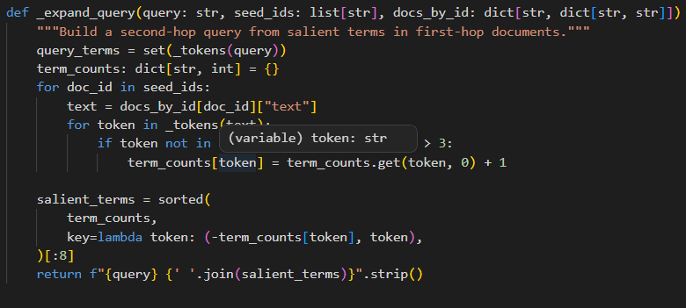
The 3.1 system focused primarily on direct fact retrieval, while the 4.1 evaluation set includes more challenging retrieval tasks, such as multi-hop nationality questions, questions requiring synthesis of two articles, comparison questions, publication date comparison. Examples:
"What common theme links Sailor Moon and Dragon Ball Z?"
"Which came first: the debut of the Earthsea series ... or the first publication of the manga that inspired Dragon Ball Z?"
Checkpoint 4.1 also introduces several retrieval refinements, like the inclusion of STOPWORDS, which imnproves retrieval precision by reducing noise from common terms.
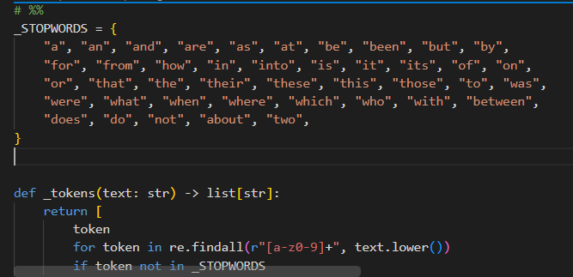
The new multi-hop retriever combines evidence from two retrieval stages:
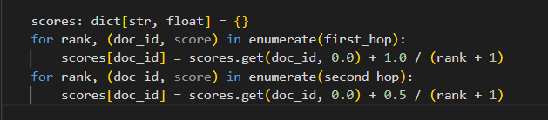
Compared to the previous system in 3.1 which only ranked documents once using normalized BM25 and vector scores and returned the final ranking immediately the new approach allows documents discovered in either hop to contribute to the final result set.
And lastly, 4.1 introduces a correctness metric as well.
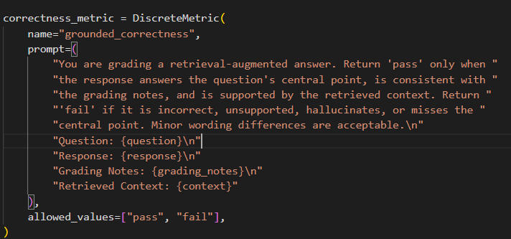
This provides stronger grounding because the evaluator can verify whether retrieved evidence actually supports the generated response.

Implementation evidence (e.g., screenshots, code snippets, retrieval outputs, notebook excerpts)
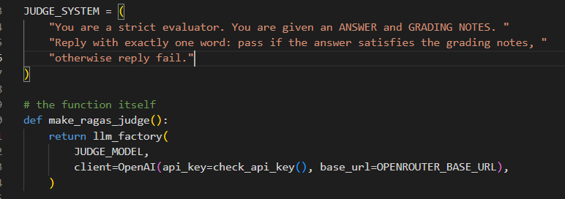
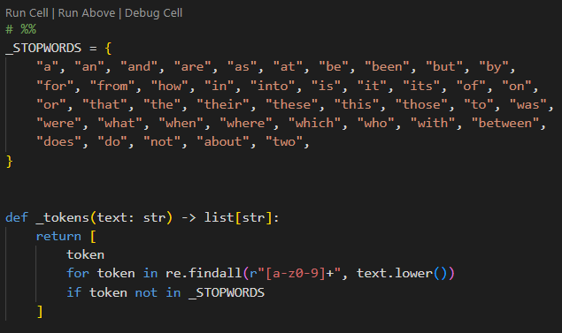
Also added this section to reduce API cost:
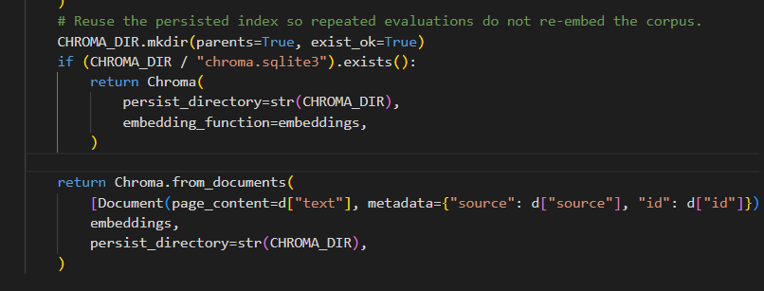
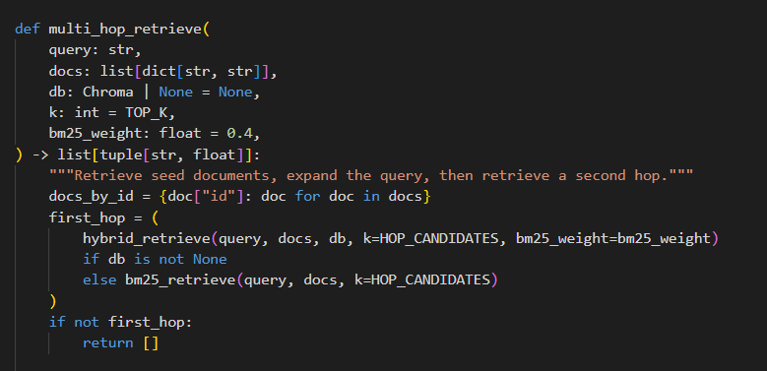
Lastly, I also added an “offline” function to test my base corpus without the API usage. This mode only uses BM25:
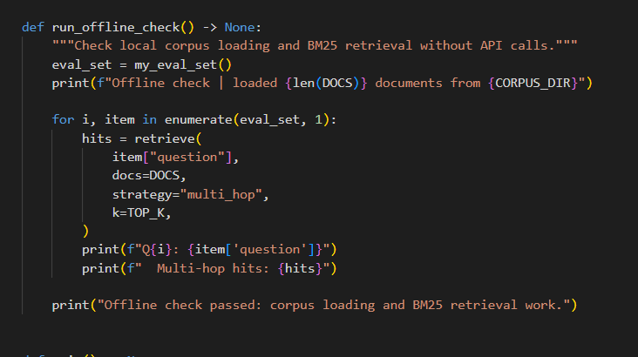

Step 5. Evaluation Results
Evaluate the updated system using the evaluation framework developed in previous modules.
- Present evaluation results.
- Compare performance against the baseline system.
- Include representative examples.
Evaluation Metric | Baseline Result | Updated Result
Total Questions Evaluated | 5 | 13
Questions passed | 5 | 7
Questions failed | 0 | 6
Pass rate | 100% | 53.8%
Single-Document Fact Retrieval | Strong performance; all tested factual queries passed | Generally strong; Uranium, Ana de Armas, Weird Al, Earthsea chronology, and Tasmania marsupial questions passed
Multi-Document Reasoning | Not extensively tested | Mixed performance; Earthsea vs. Dragon Ball chronology passed, but Sailor Moon/Dragon Ball synthesis failed
Comparison Questions | Not evaluated | Failed on Sailor Moon vs. Tasmania comparison
Hallucination Resistance | Passed "unrelated articles" test | Passed both "unrelated articles" and unsupported Ana de Armas/"The Mother" relationship questions
Retrieval Architecture | Hybrid BM25 + Vector Retrieval | Multi-Hop Retrieval with Query Expansion + Hybrid Retrieval
Evaluation Method | LLM judge (pass/fail) | RAGAS Grounded Correctness Metric

Example 1: Query, retrieved information, and result
“The actress whose international breakthrough came from Blade Runner 2049 shares what nationality with individuals born in the same country?”
Retrieved Information:
- Ana de Armas (score: 1.5)
- Academy Award for Best Production Design (score: 0.625)
- Clint Eastwood (score: 0.5)
The system correctly identified Ana de Armas and determined that she is a Cuban and Spanish actress. The response received a PASS verdict. This demonstrates successful multi-hop retrieval and entity reasoning.

Example 2: Query, retrieved information, and result
Which came first: the debut of the Earthsea series by Ursula K. Le Guin or the first publication of the manga that inspired Dragon Ball Z?
Retrieved Information:
- A Wizard of Earthsea (score: 1.5)
- Ursula K. Le Guin (score: 0.667)
- Akira Toriyama (score: 0.583)
The system correctly retrieved publication information from multiple sources and concluded that A Wizard of Earthsea (1968) predates Dragon Ball (1984). The answer received a PASS verdict.

Example 3 (optional)
What common theme links Sailor Moon and Dragon Ball Z?
Retrieved Information:
- Dragon Ball Z (score: 1.25)
- Sailor Moon (score: 1.0)
- Naoko Takeuchi (score: 0.5)
The retriever successfully identified both relevant articles, but the model responded that it could not determine a common theme and received a FAIL verdict. This example illustrates that retrieval quality improved, but cross-document synthesis and answer generation remain a limitation.

Step 6. Architectural Impact Analysis
Analyze the impact of the retrieval strategy.
- What improved?
- What remained challenging?
- Did the strategy address the original failure?
Improvements observed
The introduction of the multi-hop retrieval strategy improved the system's ability to handle questions that require reasoning across multiple entities or documents. Unlike the 3.1 baseline, which primarily focused on direct fact retrieval, the 4.1 system successfully answered more complex questions involving indirect references, temporal comparisons, and entity linking. For example, it correctly determined that A Wizard of Earthsea (1968) was published before Dragon Ball (1984) by retrieving and combining information from multiple related articles. It also successfully resolved the indirect query about Ana de Armas's nationality and identified the connection between "Eat It" and Michael Jackson.
The updated strategy also improved robustness against hallucinations. Questions designed to contain insufficient information, such as the relationship between Ana de Armas and The Mother, were correctly answered by stating that no supporting evidence existed in the retrieved documents

Remaining limitations or challenges
In several failed cases, the retriever successfully found the relevant documents, but the LLM could not use that information effectively. For example, for the Tasmania query, the top retrieved document was Tasmania, yet the model incorrectly stated that the documents did not contain the answer and failed to identify the Tasmanian devil.
Similarly for "What common theme links Sailor Moon and Dragon Ball Z?" the system correctly retrieved both Sailor Moon and Dragon Ball Z, but failed to synthesize a shared theme from the provided context like heroism, fight against forces of evil, family or friendship.
Comparison questions also remained difficult. The system retrieved both Sailor Moon and Tasmania for a subject-matter comparison question but was unable to generate the expected comparison answer.
These examples suggest that retrieval is no longer the primary blockage - reasoning and synthesis over retrieved evidence remain major challenges.

Did the strategy address the original failure?
Partly. The original limitation identified in Checkpoint 3.1 was the system's inability to support cross-document reasoning and relationship discovery. The baseline retriever returned individual documents but lacked mechanisms for multi-step retrieval, query expansion, and linking related concepts across articles.
The 4.1 multi-hop strategy directly addressed this limitation by introducing a second retrieval stage and query expansion. Evidence of this improvement can be seen in questions that required information from multiple sources, such as the Earthsea versus Dragon Ball publication-date comparison and the indirect Ana de Armas nationality question, both of which passed evaluation.
However, the strategy did not completely solve the problem. While it improved retrieval and document discovery, some cross-document synthesis questions still failed despite retrieving the correct evidence. Therefore, the original retrieval limitation was reduced, but it was replaced by a new limitation: the model's ability to reason over and combine retrieved information effectively.
Overall conclusion: The multi-hop retrieval strategy successfully improved document discovery and support for multi-document queries, addressing a key weakness of the baseline system. However, challenges remain in answer generation, comparison, and synthesis, indicating that future improvements should focus on reasoning and reranking rather than retrieval alone.

Step 7. Reflection and Next Steps
Reflect on the effectiveness of the architectural redesign.
- What did you learn from implementing this strategy?
- What would you improve next?
- Are there additional retrieval failures that still need to be addressed?
Reflection on the architectural redesign
Implementing the multi-hop retrieval strategy demonstrated that improving retrieval is not simply about retrieving more documents, but about retrieving documents that support reasoning across multiple entities and concepts. The redesign showed that query expansion and multi-hop retrieval can improve the system's ability to answer complex questions that require information from multiple articles.
Another important lesson was that retrieval and answer generation are separate challenges. Several failed cases showed that the retriever successfully identified the correct documents, but the LLM was unable to synthesize the information into a correct response. This indicates that retrieval quality alone does not guarantee answer quality.

Specific improvements or next steps
Potential improvements would include implemnenting document chunking and passage – level retrieval, instead of retrieving entire articles, introducing explicit comparison and synthesis prompts for multi-document questions.
I’m not entirely sure if graph techniques could be used for my corpus now that it has been converted to texts therefore losing the hyperlinks.
But bottom line is, that he next improvement would focus on reasoning and reranking rather than retrieval alone.

End of Required Capstone Checkpoint 4.1
Return to the assignment page in the learning platform to upload and submit your completed capstone checkpoint and complete any remaining items in this module.

